KAMPALA JUNIOR ACADEMY

HOLIDAY WORK SET TWO TERM I 2020
LITERACY I
PRIMARY ONE

My name is ________________________________________________
School _____________________________________________________
1. Fill in the missing letter.
(a) c__t (b) d__g (c) go__t

2. Write these words correctly.
rlgi _________ (b) ircha _________ (c) bleta _______

3. Fill in the missing days of the week.
(a) Sunday, ________________, Tuesday, Wednesday, _________________, Friday, Saturday.
(Thursday, Monday)

4. Read and draw
pot | hat | table

5. Match people to their places of work.
gatekeeper kitchen
cook classroom
teacher gate
6. Read and write Yes or No
(a) A teacher cooks food at school. ________________
(b) We go to school to learn. _____________
(c) I have six eyes. ______________

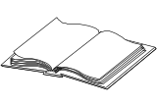
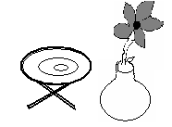
7. Name the pictures.
(a) __________ (b) ____________

(c)  _____________

8. Write the odd word from the list.
(a) (b)
bursar
cook
food
book
mat
pencil

____________ _____________

9. Read and answer the questions.
This is the boy. His name is John. He is playing football. Peter is his brother.
(a) The boy’s name is _________________.
(b) He is playing __________________.
(c) His brother is called _________________.
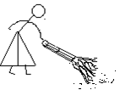
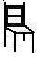
10. Match correctly
(a) for writing with.
(b) for sweeping.
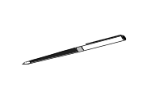
(c) for sitting on.

11. Complete these riddles correctly.
(a) I am round. You kick me during play time.
What am I? ______________________________________

(b) I am made of wood. You put books on me. I have four legs. What am I? _____________________________

(c) I have a round face. I stay on walls in classroom.
I also live in offices. My work is to tell time.
What am I? _____________________________________
12. Read and draw pictures.
(a) The bird is on the tree.

(b) Musa is reading a book.

(c) There are three stars.

13. Answer correctly (Yes, it is/No, it is not)

(a) Is this a book? ____________________

(b) Is this a flower? ____________________
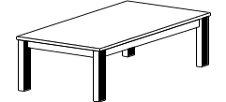
(c) Is this a chair? ______________________
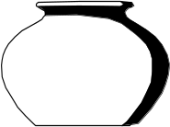
(d) Is this a pot? _______________________

14. Fill in the correct word from the brackets.
(a) There are _______________ days in a week.
(four, ten, seven)

(b) A ______________ is a domestic animal. (got, goat)
(c) People go to church on _________________.
(Sunday, Sandy)

(d) We drink water from a _______________. (grass, glass)

15. Write these sentences correctly.
- hat a has Dad.
___________________________________________________
- an apple I have.
___________________________________________________
- a is This cat.
__________________________________________________
16. Fill in the missing words from the table below.
Parts of My Body
God gave me gifts on my body. I have to use them well to make Him happy. He gave me ________________ to see. I have ______________ to touch, clap and hold things. I use my ________________ for hearing. I use the _____________ to talk and eat food. My ______________ help me to walk from one place to another.
eyes, hands, ears mouth legs
--END--

